Orators Report
on the 22nd Degree
Knight of the Royal Axe
or Prince of Libanus
Mar 6, 2013
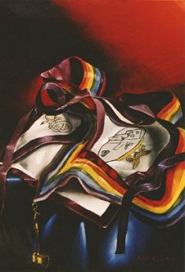

The apron is white, bordered in purple, and contains a three-headed serpent denoting the ignobility of idleness and a table with instruments and plans on it.
Bremerton Valley of the Scottish Rite
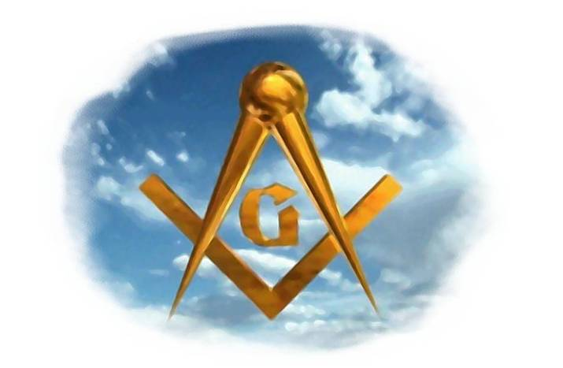
The Legend: The Council of Kadosh comprises the Nineteenth through the Thirtieth Degrees. The word Kadosh is Hebrew, and means “consecrated or dedicated.” Its members are dedicated to the discovery of philosophic truths and the chivalric virtues. This is the fourth Degree of the Council of Kadosh. This degree explains that the Druse perpetuated an institution originating in Rome about 700 B.C. called Colleges of Artificers which are simply described as operative of artisans, such as carpenters or goldsmiths. Parallels between these Colleges and Freemasonry exist which have caused some scholars to trace the roots of Masonry to them. Although only a legend, the ritual suggests that the Colleges of Rome may have been derived from the ancient people who inhabited the Mount Lebanon area and supplied cedar for the building of Noah's Ark, the Ark of the Covenant and King Solomon's Temple. This legend accounts for bodies of this degree being called Colleges, the events in the drama and much of its symbolism.
The Setting: The time is the Middle Ages, the candidate comes dressed as a German (or Prussian) Knight, a crusader in the Holy Land. He has traveled to Mount Libanus (or Lebanon) to obtain the degree of Prince of Libanus. The drama takes place in two areas: One is represented as a carpenters workshop on Mt. Lebanon. The other is the Council Room of the Round table; In the center of this apartment is a round table at which the brethren sit. The table denotes equality as it did for the knights of King Arthur.
The Ritual: The candidate is first received in the Council Room and seeks to become a Prince of Libanus by privilege, birth, and rank. This is declared insufficient. The candidate must divest himself of the jewels and adornments of his rank and labor among the workmen, show a true appreciation for the dignity of labor, and obtain the workmen's unanimous vote to advance.
The candidate is placed in the carpenters workshop and taught how to use the tools of the Craft: the saw, plane, and axe. The saw symbolizes patience and determination; it teaches us that Masons, laboring for the improvement of the world and the cause of human progress, must be content to move slowly and painfully to success. The plane cuts down the inequalities of surfaces, it symbolizes Masonry which removes the prejudice of ignorance and aids to civilize mankind. The axe should remind the Mason of the march of civilization and progress which requires him to hew the poisonous trees of intolerance, bigotry, superstition, uncharitableness and idleness to let in the light of truth and reason upon the human mind.
The Lecture: As in the 20th degree, this degree teaches us that Masonry is essentially WORK; both teaching and practicing LABOR. We are taught that work is the mission of man, not a curse, but the fulfillment of life’s purpose. Our daily labor, if fit and proper, receives the blessing of God.
The central idea of the Degree is the dignity of work and, hence, the ignobility of idleness. Each person has a responsibility to be productive, not just in his own life but in the lives of others.
In a beautiful passage, Pike shows that the axe is more noble than the sword, for the sword can be and is used as a means of conquest and subjugation. But in the hands of the pioneer, the axe becomes the instrument for the spread of civilization. Thus the axe is far more likely than the sword to be used as an agent of benefit to humanity.
The Scottish Rite Mason who holds the 22° is pledged to the support of civilization and culture and, above all, to work to assure those goals. As Albert Pike wrote in Morals and Dogma (p. 350): Masonry seeks to ennoble common life. Its work is to go down into the obscure and unsearched records of daily conduct and feeling; and to portray, not the ordinary virtue of an extraordinary life; but the more extraordinary virtue of ordinary life. What work is done and borne in the shades of privacy, full of uncelebrated sacrifices; in the long strife of the spirit, resisting pain, penury, and neglect, carried on in the inmost depths of the heart; —what is done, and borne, and wrought, and won there, is a higher glory and shall inherit a brighter crown.

THE LESSONS of this degree have always been of great moment to a large number of people. The respect for labor itself and sympathy for the laboring classes are purely Masonic. Masonry has made the working man and his associates the heroes of her principal legend, and himself the companion of kings. From first to last, Masonry is work. Labor is man's great function, his peculiar distinction and his privilege. He pours his own thoughts into the molds of nature, fashioning them into forms of grace and fabrics of convenience. But greater than these, every man has work to do in himself, upon his own soul and intellect, and so may attain the highest nobleness and grandeur on earth or in Heaven.

DUTIES:
Respect labor for its own sake, and do work.

FOR REFLECTION:
If one finds for himself esteem in his labors, does the prestige associated with his labors matter?

IMPORTANT SYMBOLS:
The cedars of Lebanon, carpenter' tools: saw, plane and axe.
The apron is white, bordered in purple, and contains a three-headed serpent denoting the ignobility of idleness and a table with instruments and plans on it. The jewel is an axe and handle of gold.

This report is based on excerpts from: "Toward the Light, The Work" – 1999, Orient of Oklahoma; "Bridge To Light" – 2006, Rex Hutchins; "Scottish Rite Ritual, Monitor and Guide" – 2007, Arturo de Hoyos.

Adapted from the Spanish version of Rex R. Hutchen’s book A Bridge to Light

